ASSIGNMENT – 1
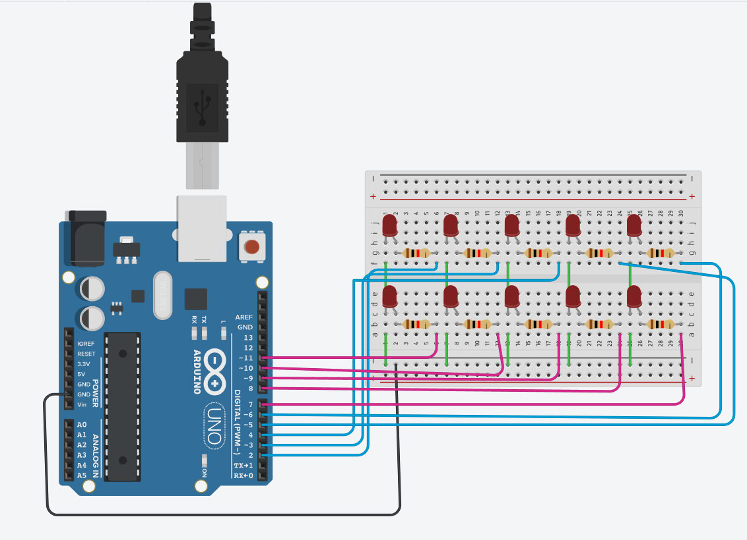
Omprakash Reddy – G19 ES&IOT
Code:
int led[] = {2, 3, 4, 5, 6, 7, 8, 9, 10, 11};
int pattern1[] = {2, 3, 4, 5, 6, 11, 10, 9, 8, 7};
int pattern2[] = {2, 7, 3, 8, 4, 9, 5, 10, 6, 11};
int pattern3[] = {7, 8, 9, 10, 11, 6, 5, 4, 3, 2};
int pattern4[] = {6, 11, 5, 10, 4, 9, 3, 8, 2, 7};
void setup()
{
for(int i = 0; i < 10; i++)
{
pinMode(led[i], OUTPUT);
}
}
void loop()
{
int pattern = random(0, 4);
for(int i = 0; i < 10; i++)
{
if(pattern == 0)
digitalWrite(pattern1[i], HIGH);
else if(pattern == 1)
digitalWrite(pattern2[i], HIGH);
else if(pattern == 2)
digitalWrite(pattern3[i], HIGH);
else
digitalWrite(pattern4[i], HIGH);
delay(500)
if(pattern == 0)
digitalWrite(pattern1[i], LOW);
else if(pattern == 1)
digitalWrite(pattern2[i], LOW);
else if(pattern == 2)
digitalWrite(pattern3[i], LOW);
else
digitalWrite(pattern4[i], LOW);
}
}

